


Tenant Satisfaction Measures – Summary of Approach 2024/25
Brighton & Hove City Council

Table of Contents
Introduction 3
Summary of Achieved Sample & Sample Method 3
Timing of Survey 4
Collection Method(s) 4
Sample Method 4
Representativeness 5
Questionnaire 8

Introduction

The Tenant Satisfaction Measures (TSM) Standard mandates that all registered providers develop and report TSMs in accordance with the guidelines set by the regulator. As part of this requirement, it is necessary for Brighton & Hove City Council (Brighton & Hove CC) to inform its customers about its approach to conducting the TSM Perception survey and collecting data.
This document details Brighton & Hove CC’s methodology and outlines the criteria specified in the Regulator of Social Housing’s publication, Tenant Satisfaction Measures Return.
The Tenant Satisfaction Measures (TSM) Standard requires all registered providers to conduct tenant perception surveys and report performance annually as specified by the RSH. TSMs are intended to make landlords’ performance more visible to tenants so that tenants can hold their landlord to account. TSMs consist of 22 measures: 10 providing management information from data held by the landlord and 12 satisfaction measures gathered from tenant surveys. In addition to overall satisfaction with landlord services, the measures cover five key themes:
- Keeping properties in good repair
- Maintaining building safety
- Respectful and helpful engagement
- Responsible neighbourhood management
- Effective handling of complaints
Providers must publish a summary of the survey approach used to generate published tenant perception measures. This must be made clearly available alongside each set of tenant perception measures published by the provider.

Summary of Achieved Sample & Sample Method

Brighton & Hove CC works with Acuity Research & Practice Ltd, an accredited organisation that is dedicated to providing research services in the social housing sector. We use survey information to understand how our tenants feel about their homes and services and how we can improve. Acuity was commissioned for collecting, generating and validating reported perception measures.
In 2024/25, Brighton & Hove CC completed TSM surveys with a sample of residents. The sample size was chosen to ensure that the level of statistical accuracy set out by the Regulator of Social Housing was met. Brighton & Hove CC must ensure that they survey enough residents to meet a statistical accuracy (margin of error at 95% confidence interval) of +/- 3.0%.
During 2024/25, Brighton & Hove CC completed 1,377 TSM surveys. Brighton & Hove CC have 12,400 occupied properties which means that a statistical accuracy level of +/- 2.5% was achieved, which is a greater level of accuracy than required.
No tenant was removed from the sample frame.
No incentives were offered.

Timing of Survey

Brighton & Hove CC completed a total of 1,377 surveys between 04/10/2024 and 09/01/2025.

Collection Method(s)

The TSM Surveys were completed via telephone only. The rationale for using a mixed methodology approach is:

- Accessibility and Inclusivity: Telephone surveys ensure accessibility for all tenants, especially those who may not have internet access or digital skills, which aligns with our goal of reaching a broad and representative sample.
- Engagement and Data Quality: Direct interaction over the phone tends to enhance engagement, allowing participants to answer clarifying questions and leading to more accurate and detailed responses. This is particularly valuable for nuanced satisfaction metrics.
- Response Rates: Historically, telephone surveys have yielded higher response rates than other methods within this tenant demographic, maximising the robustness of our data and ensuring the results truly reflect the tenant base. Using a telephone interaction allows Brighton & Hove CC to be reactive to flags and alerts, which improves customer recovery.
- Reliability and Consistency: Maintaining consistency with previous years' methodologies allows for more reliable trend analysis. A telephone-based approach helps ensure the comparability of responses across survey years, supporting more insightful year-over-year analyses.
- Independence: Using Acuity, an independent market research agency, means that participants are free from influence from the rest of the organisation.

Sample Method

A sample approach was used for Brighton & Hove CC. Acuity contacted a random selection of current tenants to participate in a telephone survey based on quotas set out by Brighton & Hove CC. The survey is carefully scripted to ensure a professional and consistent process.
Survey responses are immediately shared with Brighton & Hove CC, who then manage a follow up and review process which includes both responding to feedback as necessary and analysing the feedback, to understand how we can improve.

Representativeness

Representative checks were carried out to ensure that the survey was representative of the tenant population as a whole. The characteristics by which representativeness was determined were:

Tenure Type | Population | Sample
General Needs | 88% | 87%
Senior Housing | 7% | 7%
Temporary Social Housing | 5% | 5%

Ward Name | Population | Sample
Whitehawk & Marina | 17% | 18%
Moulsecoomb & Bevendean | 10% | 10%
Hangleton & Knoll | 10% | 10%
Queen's Park | 10% | 11%
Coldean & Stanmer | 7% | 7%
Hollingdean & Fiveways | 7% | 7%
Kemptown | 7% | 7%
Patcham & Hollingbury | 5% | 5%
Hanover & Elm Grove | 4% | 5%
Woodingdean | 4% | 3%
South Portslade | 4% | 3%
North Portslade | 3% | 4%
Wish | 3% | 3%
Goldsmid | 3% | 3%
West Hill & North Laine | 2% | 2%
Round Hill | 1% | 1%
Westbourne & Poets' Corner | 1% | 1%
Preston Park | 1% | 0%
Central Hove | 1% | 1%
Regency | 0% | 0%
Rottingdean & West Saltdean | 0% | 0%
Westdene & Hove Park | 0% | 0%
Brunswick & Adelaide | 0% | 0%
Outside Brighton & Hove | 0% | 0%

No. of bedrooms | Population | Sample
0 | 5% | 4%
1 | 32% | 28%
2 | 38% | 37%
3 | 22% | 28%
4 | 2% | 3%
5 | 0% | 1%
6 | 0% | 0%
Unknown | 0% | 0%

Age Group | Population | Sample
0 - 24 | 2% | 2%
25 - 34 | 10% | 10%
35 - 44 | 18% | 16%
45 - 54 | 19% | 16%
55 - 59 | 13% | 11%
60 - 64 | 12% | 12%
65 - 74 | 15% | 17%
75 - 84 | 9% | 9%
85 + | 3% | 2%
Unknown | 0% | 4%

Property Type | Population | Sample
Flat | 58% | 47%
House | 33% | 42%
Bedsit | 5% | 4%
Bungalow | 2% | 4%
Maisonette | 1% | 3%

Panel Area | Population | Sample
North | 31% | 30%
West | 25% | 25%
Central | 23% | 24%
East | 21% | 21%
Outside Brighton & Hove | 0% | 0%

Ethnicity | Population | Sample
Arab | 0% | 0%
Asian and White | 0% | 0%
Bangladeshi | 1% | 1%
Black African | 3% | 3%
Black African and White | 1% | 0%
Black Caribbean | 0% | 0%
Black Carribean and White | 0% | 0%
Black Other | 0% | 1%
Chinese | 0% | 0%
Gypsy Or Irish Traveller | 0% | 0%
Indian | 0% | 0%
Irish | 1% | 1%
Mixed Other | 1% | 1%
Not Known | 2% | 2%
Other Asian | 1% | 1%
Other Groups | 2% | 2%
Pakistani | 0% | 0%
Prefer Not To Say | 8% | 8%
White British | 74% | 74%
White Other | 5% | 5%

Disability | Population | Sample
Yes | 51% | 54%
None | 49% | 46%

Gender | Population | Sample
Female | 60% | 66%
Male | 40% | 34%
Nonbinary | 0% | 0%
None | 0% | 0%
Other | 0% | 0%

Questionnaire & Introductory Text

Here is the introductory text and question set used for Brighton & Hove CC’s TSM survey:

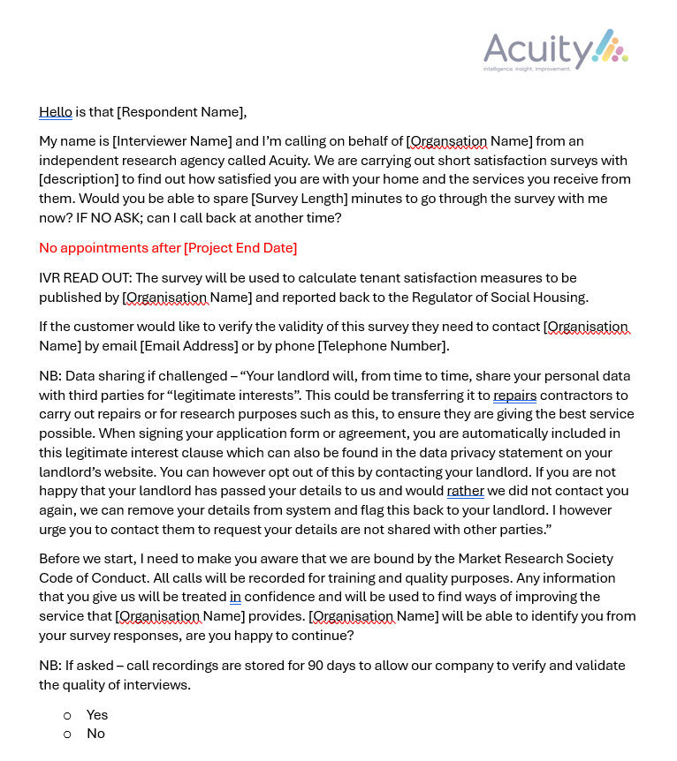

Label | Question text | Rating scale
Overall Satisfaction | Taking everything into account, how satisfied or dissatisfied are you with the service provided by Brighton & Hove City Council? | Very satisfied, Fairly satisfied, Neither satisfied nor dissatisfied, Fairly dissatisfied, Very dissatisfied
Well Maintained Home | How satisfied or dissatisfied are you that Brighton & Hove City Council Housing Services provides a home that is well maintained? | Very satisfied, Fairly satisfied, Neither satisfied nor dissatisfied, Fairly dissatisfied, Very dissatisfied
Safe Home | Thinking about the condition of the property or building you live in, how satisfied or dissatisfied are you that Brighton & Hove City Council Housing Services provides a home that is safe? | Very satisfied, Fairly satisfied, Neither satisfied nor dissatisfied, Fairly dissatisfied, Very dissatisfied, Not applicable / Don't know
Communal Areas? | Do you live in a building with communal areas, either inside or outside, that Brighton & Hove City Council Housing Services is responsible for maintaining? | Yes / No / Don't know
Communal Area Satisfaction | How satisfied or dissatisfied are you that Brighton & Hove City Council Housing Services keeps these communal areas clean and well-maintained? | Very satisfied, Fairly satisfied, Neither satisfied nor dissatisfied, Fairly dissatisfied, Very dissatisfied
Repairs in last 12 months? | Has Brighton & Hove City Council Housing Services carried out a repair to your home in the last 12 months? | Yes/No
Repairs last 12 months satisfaction | How satisfied or dissatisfied are you with the overall repairs service from Brighton & Hove City Council Housing Services over the last 12 months? | Very satisfied, Fairly satisfied, Neither satisfied nor dissatisfied, Fairly dissatisfied, Very dissatisfied
Time taken repairs | How satisfied or dissatisfied are you with the time taken to complete your most recent repair after you reported it? | Very satisfied, Fairly satisfied, Neither satisfied nor dissatisfied, Fairly dissatisfied, Very dissatisfied
Listens to views & acts upon them | How satisfied or dissatisfied are you that Brighton & Hove City Council Housing Services listens to your views and acts upon them? | Very satisfied, Fairly satisfied, Neither satisfied nor dissatisfied, Fairly dissatisfied, Very dissatisfied, Not applicable / Don't know
Keeps you informed | How satisfied or dissatisfied are you that Brighton & Hove City Council Housing Services keeps you informed about things that matter to you? | Very satisfied, Fairly satisfied, Neither satisfied nor dissatisfied, Fairly dissatisfied, Very dissatisfied, Not applicable / Don't know
Fairly and with respect | To what extent do you agree or disagree with the following `Brighton & Hove City Council Housing Services treats me fairly and with respect`? | Strongly Agree, Agree, Neither Agree nor Disagree, Disagree, Strongly Disagree, Not Applicable/Don't Know
Managed Services | How satisfied or dissatisfied are you that Brighton & Hove City Council Housing Services gives you a say in how services are managed? | Very satisfied, Fairly satisfied, Neither satisfied nor dissatisfied, Fairly dissatisfied, Very dissatisfied, Not applicable / Don't know
Getting Involved | Brighton & Hove City Council Housing Services want to improve how they communicate with their residents and resident engagement: Are you interested in getting more involved? | Yes/No
Get Involved Comments | If Yes, how would you like to get involved and what areas are you interested in? | Open Ended
Getting Further Involved? | As you are interested in getting further involved are you happy for Acuity to pass your details back to Brighton & Hove City Council Housing Services so they can contact you? | Yes/No
Complaints in last 12 months? | Have you made a complaint to Brighton & Hove City Council Housing Services in the last 12 months? | Yes/No
Barriers to Being Involved Comments | If No, are there any barriers to you getting involved? | Open Ended
Contribution to neighbourhood | How satisfied or dissatisfied are you that Brighton & Hove City Council Housing Services makes a positive contribution to your neighbourhood? | Very satisfied, Fairly satisfied, Neither satisfied nor dissatisfied, Fairly dissatisfied, Very dissatisfied, Not applicable / Don't know
Approach to ASB | How satisfied or dissatisfied are you with Brighton & Hove City Council Housing Services's approach to handling anti-social behaviour? | Very satisfied, Fairly satisfied, Neither satisfied nor dissatisfied, Fairly dissatisfied, Very dissatisfied, Not applicable / Don't know
Complaints in last 12 months? | Have you made a complaint to Brighton & Hove City Council Housing Services in the last 12 months? | Yes/No
Complaints Handling | How satisfied or dissatisfied are you with Brighton & Hove City Council Housing Services’s approach to complaints handling? | Very satisfied, Fairly satisfied, Neither satisfied nor dissatisfied, Fairly dissatisfied, Very dissatisfied
Permission 1 - Happy to be identified | The results of this survey are confidential. However, would you be happy for us to give your responses to Brighton & Hove City Council Housing Services with your name attached so that they have better information to help them improve services? | Yes/No
Permission 2 - Follow up | Would you be happy for Brighton & Hove City Council Housing Services to contact you to follow up any of the comments or issues you have raised? | Yes/No

Report by Acuity Research & Practice

01273 287114
acuity@arap.co.uk
01273 287114
01273 287114
01273 287114
01273 287114
acuity@arap.co.uk
acuity@arap.co.uk
01273 287114
www.arap.co.uk

