
Apply for a Discretionary Payment to help with rent in advance
Claim ref
What is a Discretionary Payment for rent in advance?
You can make an application for funding if you need to pay rent as a lump sum in advance of moving into a new property. The criteria for this are that you must have a current claim for Housing Benefit or Universal Credit Housing Costs that you have already found somewhere to move to, and have reached an agreement with the prospective landlord or agent.
How to apply
To help us reach a decision, answer the questions on this form. Provide as much detail as possible to help us make a fully informed decision.
Return the form to us and include:
- proof of the prospective tenancy - such as a tenancy agreement and / or an official letter from the landlord giving details of the tenancy and how much rent in advance they are asking for
- recent bank statements to confirm you cannot fund the rent in advance yourself
We will also check that the tenancy you wish to take is affordable for you and is within your Local Housing Allowance band. You can find out more about your LHA band by visiting our website www.brighton-hove.gov.uk.
Contact the Benefits Office if you need help to fill in this form. Please note a Benefits Officer cannot advise you on what to say.
Return the form along with required evidence:
- by email – dpformsandevidence@brighton-hove.gov.uk
- by post – The Benefits Service, Brighton and Hove City Council, PO Box 2929, BN1 1PS

Full name:
Current address:
Application address:
(The address you require rent in advance for)
Housing Benefit Reference: |  |  |  | National Insurance Number:
Home phone number: |  |  |  | Mobile phone number:
Email address:
How much is the rent at the new property? | £
Amount of rent in advance applied for: | £
Period rent in advance is for: | From |  | Date |  | To |  | Date
New landlord name, address and email address:
New agent name, address and email address:
Are you or any member of your household related to the landlord or agent?
If yes, give details.
Provide account details of the landlord or agent. We will pay the landlord or agent directly.
Account holder name:
Account number:  (8 digits) |  | Sort code:  (6 digits) | - | -
Roll Number:
(Building society accounts)
Name of bank or building society:
Why do you want to move to this address? For example, is it more affordable? Is it a more suitable size? Is it adapted for your needs?
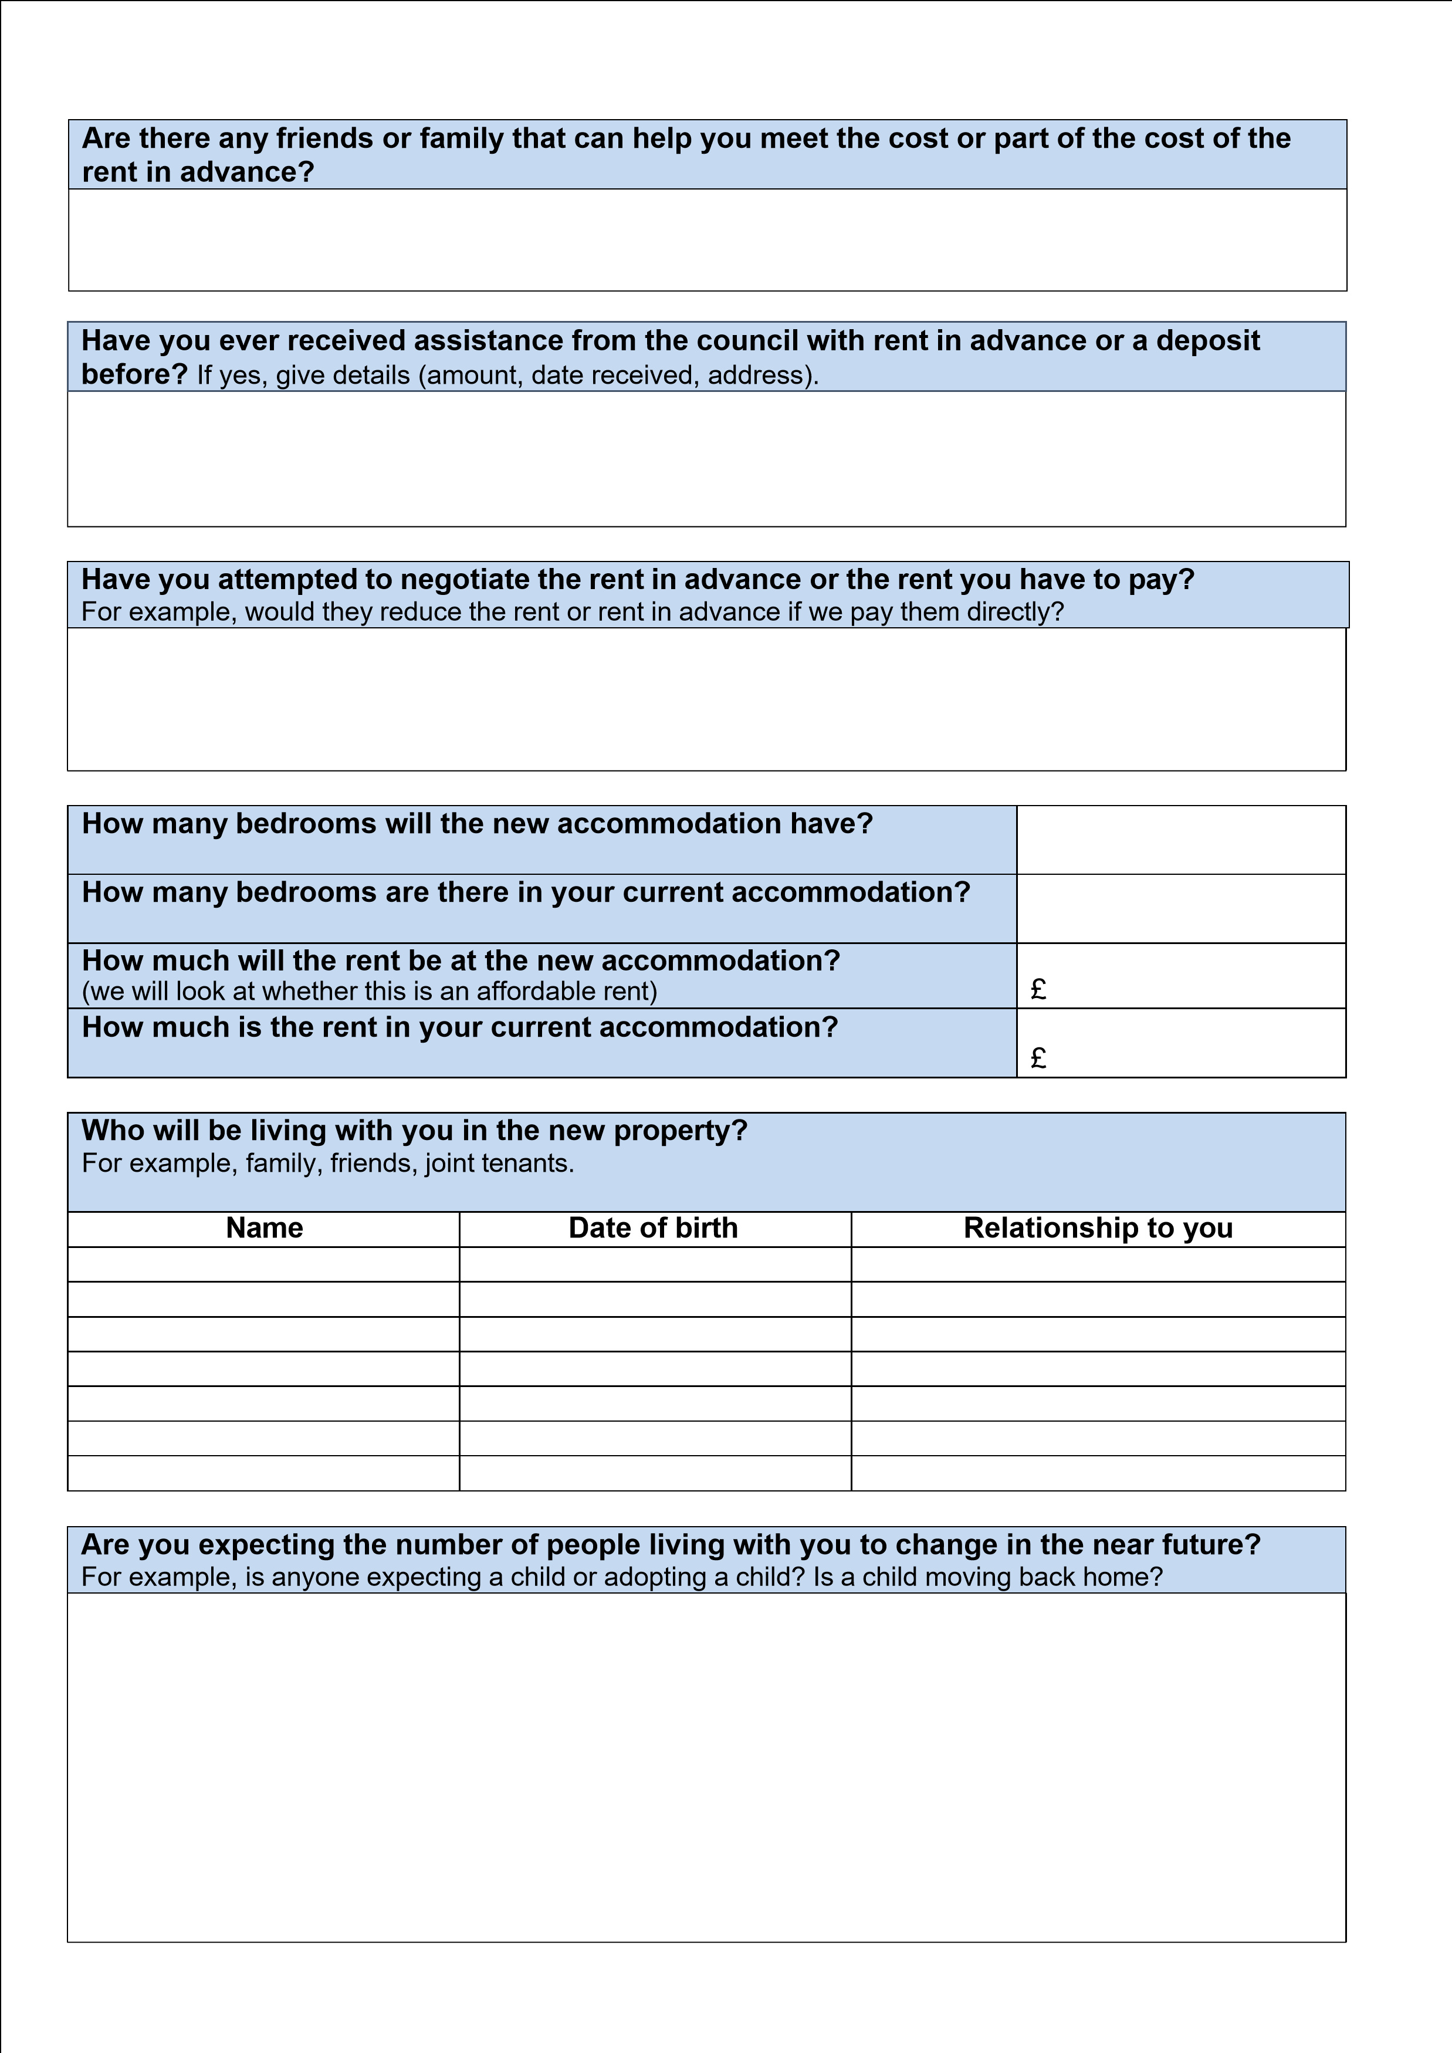
Do any children in the household require a separate bedroom for medical reasons? Provide details and documentary evidence of the medical condition.
Do you or any member of the household require an overnight carer? Give as much detail as possible. For example, how many nights do they stay over, do they normally live in your home, and will you have a spare room for the carer to stay in?
Are any non-dependants in the household able to help with the rent in advance? If so, how much? If not, explain why? A non-dependant is anybody, other than your partner or children that you receive Child Benefit for, such as a relative or family friend who lives as part of your household. The government expects non dependants to make some contribution to housing costs.
List all bank accounts belonging to you and your partner:
If there are transfers in and out of your accounts to other accounts belonging to you or your partner, we will need to see statements for these accounts too. If these are not provided with your application, it may delay or stop the decision and/or award.

Additional information
Use this space to provide any additional information which may help support you application.

Financial assessment
This section of the form is very important. Complete this section as fully as possible to help us reach a decision. You should complete the information based on your current circumstances in your current property.
Income type You (weekly) Partner (weekly)
Net earnings from employment (i.e. after deductions)
Universal Credit
Working and/or Child Tax Credit
Employment Support Allowance/Incapacity Benefit
Income Support /Job Seekers Allowance
Disability Living Allowance/Attendance
Allowance/Personal Independence Payment
Housing Benefit
Council Tax Reduction
Child Benefit
Pension
Any other state benefit
Money received from parents/friends
Any other income (please state)
Total weekly income | £ | £
Capital type You Partner
Bank accounts
Building society/Post Office accounts
Other savings
Total amount of capital | £ | £
Outgoings You (weekly) Partner (weekly)
Rent
Council Tax
Electricity
Gas
Water rates
TV Licence
Telephone
Food
Household products
Clothing
Car/transport
Maintenance
Fines
Other outgoings (please advise what they are)
Total weekly outgoings | £ | £
Credit Debts (list creditors) Balance owing Repayment offer
1.
2.
3.

Declaration
You and your partner (if applicable) must read this carefully before you sign.
- This is my / our claim for a Discretionary Payment.
- The information I / we have given on this form is correct and complete as far as I / we know
- I / we give permission to you to check the information I/we have given with any of the sections of the council, the Rent Officer, other councils and benefit authorities
- I / we give permission for you to contact my/our prospective landlord
- I / we understand that I / we must tell the council’s Benefits Team in writing about any changes in my / our circumstances that may affect my / our Housing Benefit
- I / we understand that I / we have to tell the Benefit Service about any changes to my / our Income Support, Pension Credit, Jobseekers Allowance or any other benefits.
- I / we understand that the Benefit Agency, Pension Service or Job Centre Plus are not responsible for giving this information and that I / we must tell the Benefits Team myself.
- I / we understand that the Benefit Service may use the information I / we have given on this form to detect and prevent fraud, including sharing this information with other organisations and Government departments.
- I / we understand that I / we may be prosecuted if I / we give information that is not correct or complete, or if I / we do not report any changes of circumstances, which might affect my benefit.
- I / we have read and understood this declaration.
Please sign and date the form below (if you have a partner they should also sign and date below)
Signature Date
Signature

of

applicant

Partner’s

signature

If the form was completed by someone other than the person applying, complete the following
Name

of

person

who
filled in the form

Date

Signature

of

person

Relationship

to

the
person claiming
Brighton & Hove City Council is committed to protecting your personal information. As a data controller, we have a responsibility to make sure you know why and how your personal information is being collected in accordance with relevant data protection law: www.brighton-hove.gov.uk/benefits-privacy-notice

