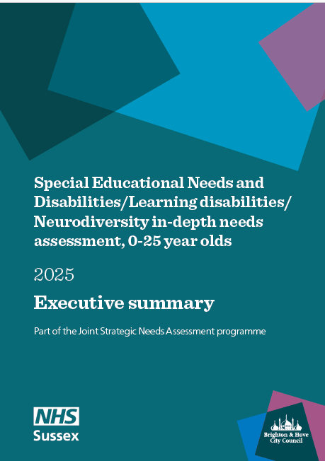

The needs assessment
Background Improving support for children with special educational needs and disabilities (SEND), learning disabilities, and neurodivergent young people is a city priority, as numbers have risen significantly both nationally and locally over the past decade. These children often face poorer outcomes in education, health, and wellbeing, with higher school absence and greater risk of being out of education, employment, or training at 16, while families experience financial strain and social isolation. Inequalities in access and outcomes are widening. There are statutory duties aimed at improving integrated support, for example, joint commissioning across health, education, and social care.
This Joint Strategic Needs Assessment (JSNA) was approved as a priority by the city’s Health and Wellbeing Board. This needs assessment and recommendations will inform local evidence-based strategies and commissioning, including the refresh of the city’s SEND strategy to replace the current 2021–2026 plan.
The aim of this needs assessment is to describe the current and future health, learning and care needs of children and young people up to 25 years old in Brighton & Hove with SEND, learning disabilities (LD) or neurodiversity (ND). Needs assessment objectives:
- To describe what is known about the prevalence and inequalities influencing health and wellbeing, learning, and care outcomes among SEND / LD / ND children and young people and their families
- To describe outcomes, trends and anticipated needs for SEND / LD / ND children and young people in Brighton & Hove​, and how they compare to other areas, including national data ​
- To review national evidence on intersectionality and how it applies locally ​
- To understand the views and experiences of parents and carers locally using existing voice data​
- To make recommendations based on the findings to inform future service provision, joint commissioning and strategic direction.
Governance The city’s SEND and Alternative Provision Partnership Board acted as the steering group. A Project Group of public health, service providers, health professionals, community and voluntary sector partners and parent carers, guided implementation, and a working group managed day-to-day delivery of the assessment.
Timeline and scope After scoping phase, the project was initiated in August 2024 and ran for 18 months. The needs assessment drew on existing evidence, intelligence and data. It includes children and young people who have an Education, Health and Care Plan or receive SEN support or both. The report includes national and local context, service provision, the level of need in B&H, evidence reviews on intersectionality, and local parent carer voice.
Within this summary, we provide the recommendations and summary of the findings.

Recommendations
The recommendations were developed by bringing stakeholders together through two workshops, where participants used the needs assessment findings to generate actionable recommendations. Evidence from local data, feedback from parent carers, and national literature on intersectionality was synthesised across four key finding areas:
- Increasing needs and demand for services
- Disproportionate impact on disadvantaged groups
- Inequalities in education and transitions
- Impacts on wellbeing and mental health
The resulting recommendations fall under the following themes:
- Inclusion
- Improve SEND identification
- Parents and carers navigating the system
- Workforce Training
- Improve support / pathways
Taking forward the JSNA recommendations
The following was discussed during the recommendation workshops and at the city’s SEND and Alternative Provision Partnership Board:
- The JSNA and recommendations to inform the refresh of the SEND Strategy in 2026
- The SEND and Alternative Provision Partnership Board to regularly review findings and recommendations of the needs assessment to ensure the JSNA keeps informing its programme of work
- Consideration is made on how Joint Commissiong is informed by the JSNA and oversight provided through the SEND and Alternative Provision Partnership Board
- Commissioners support children, young people, parents and carers to contribute to the joint commissioning process.

Inclusion

Understanding and addressing complex and intersectional factors that are barriers to children achieving
- Improve outcomes: Focus on improving outcomes for those with EHC Plans to narrow attainment gap for Brighton and Hove
- Access to support: Develop a robust local understanding on the data of children not being supported including the impact on families.
- Black and Racially Minoritised Families with SEND / LD / ND: Adopt the Council’s anti-racism in education model across all services supporting SEND children young people and families
- Neurodivergence: Adopt the approach of the council’s anti-racism model in responding to the needs of families who are neurodivergent
- Trans, Non-Binary and Intersex (TNBI) children and young people
- Recognise and mitigate the impact of national policy shifts on TNBI communities
- Acknowledge and utilise strong local practice and voice in local VCSE organisations
- Use the evidence of compound marginalisation to inform training and practice

Improve SEND identification
Enable services to support early identification of needs and prevent escalation
- Reduce variation in identification of SEN across schools by introducing moderation by review of settings with lower and higher than expected prevalence
- Use existing intersectional data, voice and evidence to better inform the targeting of resources
- Improve SEND identification through training, sharing voices, increased cultural awareness, including for:
  - Girls
  - Black and Racially Minoritised
  - Those where English isn't first language
  - Children eligible for free school meals
  - Neurodivergent children and young people

3. Parents and carers navigating the system
Information for parents and carers and support in navigating the system
- More information and support available through services that families are already accessing such as family hubs, health, housing
- Review role of newly mandated education advisors in family hubs
- Ensure all parents and carers are heard in the planning and delivery of information and support
- “Walk alongside" parents and carers meeting them where they are
- Priority groups: care experienced parents, Black & Racially Minoritised families, those where English is not their first language, parents of neurodivergent children and young people
- Ensure information is readily accessible by a range of means

4. Workforce training
Improve SEND training for staff and wider workforces to support children, young people and their parents and carers
- Review, improve and monitor SEND training for staff (social care, health, education) who work with children and young people to improve identification and support
- Increase take up by reducing barriers to accessing training
- Training to include:
    - The four areas of need in the code of practice and the local offer
- Wider ND training to develop awareness, skills and knowledge in workforces (for ND children and young people and ND parents carers)
- Tailor training: anti-stigma, anti-racism, cultural confidence, trauma informed, unconscious bias, including economically disadvantaged, care experienced, Black and Racially Minoritised communities, girls and boys - raise awareness of how behaviours are viewed / interpreted
- Train wider workforces supporting parents and carers to increase knowledge of the local offer and improve signposting and referrals
- Ensure neurodivergent staff and families can share stories, voice and experiences through training, forums and networks to address stigma, increase cultural awareness
- Make greater use of voice of those with lived experience e.g. Black and Racially Minoritised communities, with ND, those with intersectionality, school staff, girls

5. Improve support / pathways
Improve joint working across services and sectors
- Map services and bring services together to collaboratively understand clearly what their roles are in supporting children and young people
- Strengthen joint working across health, education, social care
- Ensure housing services are fully integrated in the support offer
Improve support for children and young people and parent carers across the pathways using co-design principles
- Improve support for those waiting for ND assessments
- improve support for those with identified needs but no diagnosis, as recommended in national guidance
- Increase peer support, priorities: different age groups, Black and Racially Minoritised communities
- Strengthen community support e.g. networks groups based on intersectionality to share knowledge, resources and support (contribution of VCSEs and collaboratively work with)
- Improve support for parent carers - to reduce negative impact on wellbeing, health and finances
- Review and remove barriers to engaging with support, e.g. cultural stigma
- Create accessible pathways for sharing with the wider system including parent carers
- Take a holistic approach to supporting families when school attendance drops
Mental Health and Wellbeing
- Expand alternative provision pathways to better meet mental health needs
- Use multi-disciplinary teams for joined-up, sustained support
- Review the offer for families with children and young people who display behaviours of distress
- Ensure neuro-affirming therapies are the only type offered to neurodivergent children and young people
- Support retention in school by improving the experience of safety & belonging in schools for SEND pupils

Improve support / pathways – continued
Children and young people not in education settings
- Improve support to this community with a pragmatic approach to offering support
- Identify clear ownership of the support offer
- Improve information on the needs of SEND children and young people who are not in education
Improve support for transitions from starting school to adulthood
- Use specialist support workers to guide families through services
- Ensure strategic join-up with Co-occurring Substance Use and Mental Health transitions work and the Council’s Transitions Strategy
- Ensure a multi-agency approach to transitions planning that includes health, housing, social care
- Keep children in care with complex needs nearer to the city to ensure continuity of offer
- Review and monitor a wider range of post-education outcomes for young people with SEND
- Ensure transitions data informs operational and strategic planning and delivery of services

Summary of findings
Four key areas of need emerged from the evidence gathered in the needs assessment. Evidence from local data, service provision, local parent carer feedback, and national literature on intersectionality, has been synthesised under each of these areas below.

- Increasing needs and demand for services
- Disproportionate impact on disadvantaged groups
  - Sex disparities
  - Deprivation
  - Ethnicity
  - Gender identity and sexual orientation
  - Care experienced
- Inequalities in education and transitions
- Impacts on wellbeing and mental health

Increasing need and demand for services
Local data
- One in four (24%) of all pupils aged 4 to 16 years in Brighton and Hove have special educational needs (SEN), higher than England (19.5%) in 2025
- This equates to 7,263 SEN pupils, this includes pupils with an education, health and care plan (EHC Plan) (5.8%) and pupils with SEN support (18%).
- Against overall falling pupil numbers in the city, numbers of pupils with SEN have increased by 26% in the five years Jan 2020 to Jan 2025. Numbers of pupils with an EHC plan have increased by 52% over the same time period.
- Local modelling shows that the proportion of children and young people aged 0-25 with an EHC Plan is projected to increase from 4% to 6% from 2026 to 2032.
Number of children with Special educational needs (SEN), Brighton and Hove Schools, January 2015 to January 2025
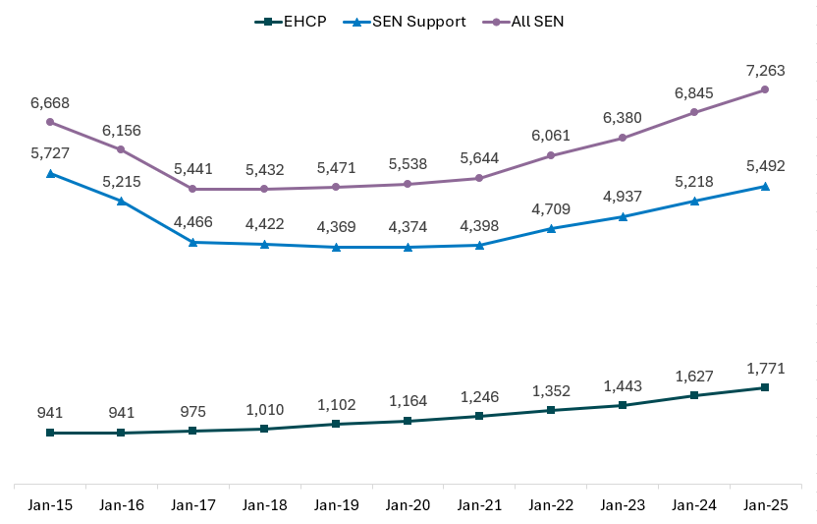
Source: Brighton and Hove Schools Census, January 2025
- There are four primary needs that account for the vast majority (88%) of SEN: Social, Emotional and Mental Health (SEMH), Specific Learning Difficulties (SpLD), Speech, Language and Communication Needs (SLCN) and Autistic Spectrum Condition (ASC).
- Since 2015, numbers with ASC have increased six-fold and SEMH has increased by 40%. This could, in part, reflect changes in diagnostic practices.
- In the city, half of pupils (48%) with an EHC plan have a primary need of autistic spectrum disorder (ASC). This is higher than in England (33%).
- Average wait time for neurodevelopment assessment in children increased from 23 weeks in September 2023 to 27 weeks in June 2024
- The number of children aged 0 to 17 years, waiting for an assessment for suspected Autism referral increased by 185% from September 2023 (170 children) to September 2024 (485 children)

Percentage of pupils receiving SEN Support (top chart) and ECHP (bottom chart), by primary SEN need, in Brighton & Hove (January 2025) and England (2024)

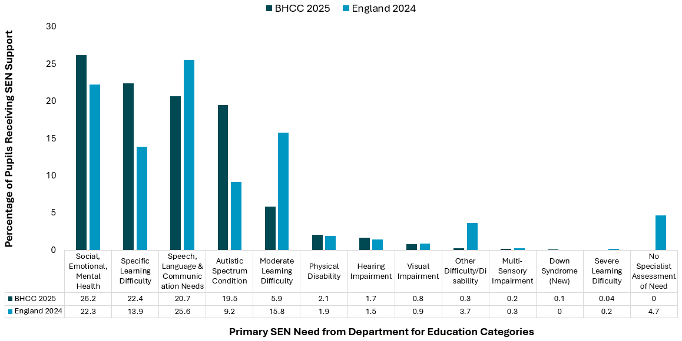
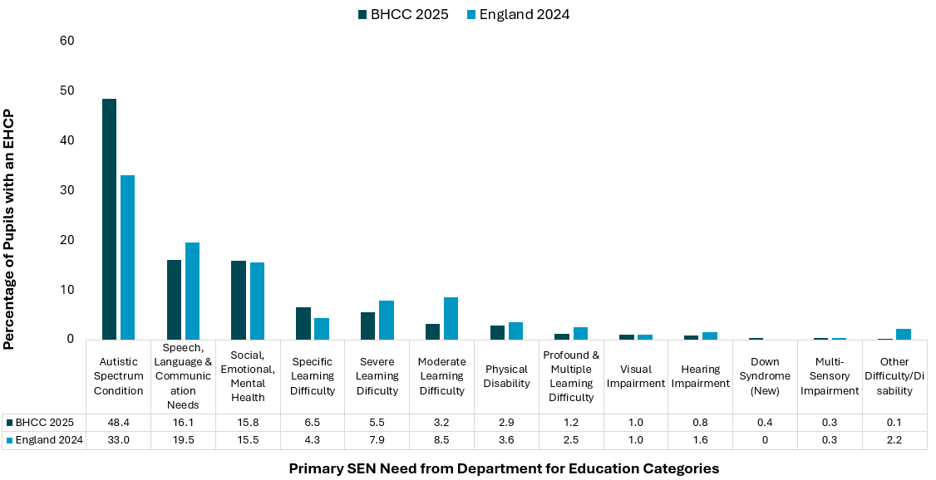
Source: Department for Education. Schools, pupils and their characteristics: January 2024, Special Educational Needs in England, 2023/24 and Brighton and Hove Schools Census, January 2025

Service provision
Local parent carer feedback
- Children and young people and parent carers challenges worsen while waiting, families need support before reaching crisis point
- Getting an assessment depends significantly on advocacy by parent carers and individual professionals
- Addressing carers support needs is essential to prevent escalating negative impacts on both carers and their families, particularly among the most disadvantaged
- Pathways are complicated and inequitable for the most disadvantaged, there is a need to simplify and support their navigation across pathways and system
Despite the breadth of SEND provision in Brighton & Hove, several opportunities for development remain:
- Neurodevelopmental (ND) assessments and support are heavily focused on Autism and ADHD, creating inequalities for individuals with other ND profiles, such as Tourette’s, Fetal Alcohol Spectrum Disorder (FASD), Avoidant/Restrictive Food Intake Disorder (ARFID), sensory processing differences, specific learning difficulties, or developmental coordination disorder
- Existing data may not reflect the complexity of need, as Autism is often recorded as the primary need even when it forms part of a broader SEND profile
- Opportunities exist to enhance joint working between providers, e.g. through combined Autism and ADHD assessments, and to create more integrated pathways and care oversight for individuals with complex or multiple needs

Disproportionate impact on disadvantaged groups
Children most affected by inequalities in SEND provision are often those who also belong to other groups that are treated unfairly. The literature highlighted that this is true for children from Black and Racially Minoritised and migrant backgrounds, those in care or care experienced and those living in families experiencing financial hardship.
Children experiencing compounding intersectional inequalities are less likely to have their needs identified early, less likely to receive appropriate support, and therefore may be more likely to experience exclusion, not do as well as expected, and experience long-term compounding disadvantage.
Below is a summary of evidence across the following:
- Sex disparity
- Deprivation
- Ethnicity
- Gender identity and sexual orientation
- Care experienced

Sex disparity
Local data: Locally boys are more likely to be identified with SEN (28% boys, 19% girls), More than twice as many males have an EHC Plan than females. These patterns mirror national data. Males are twice as likely to be on the Compass register as females
Local parent carer feedback: Parent carers report a lack of understanding and adaptations in services, especially for girls with autism and ADHD.
National literature (ref CC report): Boys are diagnosed with all neurodevelopmental conditions at higher rates, with the largest sex disparity seen in ADHD, followed by ASC. Autism diagnostic tools are largely based on male presentations, which can overlook how traits appear in girls. Girls are often underdiagnosed due to biases and because they may camouflage their difficulties, increasing the risk of unmet needs and later mental health problems. Growing recognition that reforming ADHD identification to better reflect girls’ experiences is needed.
Intersectionality: National intersectionality evidence highlights compounded disparities, for example, SEN Black Caribbean boys face additional challenges due to cultural misunderstandings, low expectations, and systemic bias in schools.

Deprivation
Deprivation is a significant and persistent factor shaping the experiences of SEND children and young people, parent carers and their families.
Local data
- The proportion of pupils with EHC plan or with SEN support increases with increasing deprivation. Over a third of those living in the most deprived areas of the city have SEN (34% compared to 18% in least deprived), and almost 1 in 10 have an EHC plan (9% compared to 3.4% in the least deprived).
- More pupils eligible for free school meals (FSM) have SEN (38% FSM, 19% not eligible for FSM). Those eligible for FSM are more than twice as likely to have an EHC plan.
- Neurodivergent young people (aged 18 - 24), those with sensory impairment or long-term physical illness are disproportionally living in more deprived areas.
Local parent carers feedback
A local survey of parents and carers identified significant financial hardship, much of it associated directly with their caring roles:
- Over two in three parent carers either do not work, have reduced their hours or the seniority of their work role due to their caring responsibilities.
- Over a quarter of parent carers of SEN children and young people are experiencing significant economic hardship, often intensified by the demands of their caring responsibilities (e.g. affecting ability to work), contributing to a persistent cycle of deepening inequality
- Financial and housing issues are important barriers mentioned by parent carers
- Low income and single parent families say that affording childcare is a challenge associated with isolation and lack of peer support
- Almost one in five responded yes to “Do you ever reduce the size of your meals or skip meals for the family because there isn’t enough money for food?”
National literature: The national literature reviewed highlighted deprivation as a significant factor shaping the experiences of SEND children and young people, particularly in access to support. Family economic deprivation was associated with increased unmet need for early support for young children with developmental disability. Parents having to give up work to support children at home. Class intersects with disability causing inequality of access to in-school support in mainstream secondary school settings.

Ethnicity
Local data
- White British pupils are more likely to have recorded SEN (26%) than Black and Racially Minoritised pupils (19%) locally, but there are important differences across communities – with White Gypsy, Roma and Traveller communities most likely to have recorded SEN (46%).
- Those who have English as an additional language are less likely to have recorded SEN locally, 25% of pupils who do not have English as an additional language compared to 18% of pupils who do.
National literature
Local parent carers feedback
Parent carers families from Black and Racially Minoritised backgrounds share that cultural stigma, awareness and language can be a barrier to engaging with support and that they value peer groups, community groups and mentoring. Parent carers expressed the need to:
- Strengthen awareness for families and professionals
- Improve diagnostic tools - making them culturally sensitive/appropriate and addressing evaluator bias
- Ensure better access to interpreting services for families
- Increase inclusion and diversity training for schools and police
- Strengthen trauma-informed practice
- Increase the diversity of staff and trainers
- More consultation with people with lived experience to co-design of services
- Strengthen and signpost to VCSE support for Black and Racially Minoritised families
National literature highlights the following:
- Under and over representation of Black and Racially Minoritised SEN pupils, including, role of racial bias and social understanding of different presentations
- Families from Black and Racially Minoritised backgrounds reported widespread experiences of discrimination, dismissal by school professionals, and lack of accessible information - especially those with limited English proficiency
- In some communities, there may be limited awareness or differing understandings of conditions like autism, which can result in delayed diagnosis
- A need for training for professionals to improve ability to differentiate between language difficulties and learning disabilities is needed Parents report they or their children faced discrimination / bias / racism based on their appearance, and that children being bullied because of their ethnicity received little support from school.
Intersectionality
There is a clear relationship between deprivation and ethnicity. National study findings indicate that ethnic differences in ASC diagnosis are closely linked to socioeconomic disadvantage. Emerging evidence also highlights the compound effects of intersectional inequalities, for example, the intersections of Black or racially minoritised, socioeconomic disadvantage, sex/gender and SEN. These intersecting factors can shape experiences and outcomes. For instance, Black boys from lower socioeconomic backgrounds are reported to encounter disproportionately low expectations within school settings.

Gender identity and sexual orientation
Our intention was to report on gender identity and sexual orientation for SEND young people separately, as they represent distinct dimensions of identity. However, this has not been possible where intersectional literature or reports have not been presented in this way.
Gaps in evidence
This needs assessment highlighted limited UK literature on experiences of LGBQ+ SEND young people or TNBI SEND young people. In addition, there were limited existing reports that captured parent carer lived experience that was specific to parent carers of LGBT+ or TNBI young people. Community organisations and providers working with marginalised groups, including those working with parent carers of LGBQ+ and TNBI young people, will not necessarily have feedback and experiences disaggregated for those parent carers of SEND young people.
Local parent carers feedback
Local health and wellbeing survey data
Gender identity
- Secondary students who do not identify with their gender at birth were more likely to report receiving extra help compared to those who did identify with their gender at birth (Key Stage 3:18% vs 9%; Key Stage 4:11% vs 5%)
- Over a third of neurodivergent young people aged 18-24 are TNBI
Sexual orientation
- Secondary school LGB+ students are more likely to report receiving “extra help”, compared to heterosexual / straight peers (Key Stage 3:13% vs 9%; Key Stage 4: 8% vs 4%)
- Just under three quarters of neurodivergent young people aged 18-24 are LGBQ+
- Young people aged 18 to 24 who were: neurodivergent, had mental health issues, a physical difference or sensory impairment were more likely to be LGBQ+ than all young people aged 18 to 24
Parent carers highlight need for community groups sessions targeted for families from groups that are currently underserved such as LGBTQ+ young people with learning disabilities.
National literature
LGBTQI+ SEND students often faced compounded marginalisation, with higher instances of bullying, a lack of tailored support, and environments that question the validity of their identities. The two papers found highlight an urgent need for further research, targeted resources, and nuanced frameworks to better support gender-diverse children and young people within SEND systems.

Care experienced
Local data
National literature
Data snapshot 2023/24 children supported by social care
- In Brighton and Hove, in 2023/24, there were 756 children who have been assessed as a child in need (CIN), 148 needing a child protection plan (CPP) and 156 who are looked after (CLA) by the local authority.
- Brighton & Hove has a higher percentage of Children in Need (38%), Children Looked After (47%) and Children on Child Protection Plan (16%) with an EHC Plan compared to England and the South East (England: CIN 30%, CLA 32%, CPP 12%. South East: CIN 33%, CLA 37%, CPP 14%).
- Brighton & Hove has a higher percentage of Children in Need (26%), and Children on Child Protection Plan (41%) on SEN support compared to England and the South East (England: CIN 22%, CPP 30%. South East: CIN 22%, CPP 31%).
- In a local survey, care experienced students were more than 2 times more likely to report that they received “extra help” in class compared to non-care experienced peers – 57% of care experienced students report receiving extra help in primary school (Key Stage 2), and 35% and 20% of Key Stage 3 and 4 respectively in secondary school
Care experienced children are disproportionately identified with SEND. Research shows that care experienced SEN pupils encounter compounded negative education outcomes, including, increased exclusion, suspension, non-enrolment/off rolling, and poorer educational achievement trajectories.

Inequalities in educational outcomes & transitions
Local data
In 2023/24, B&H SEN pupils have poorer educational outcomes throughout school and transitions in to Post 16 and progression to higher education at age 19, particularly for those with an EHC Plan. This is the same pattern as seen nationally.
Pupils with EHC Plans have worse educational attainment throughout their school life, compared to pupils with EHC Plans nationally.
- Overall absence and persistent absence increased significantly in Covid both for B&H and England
- B&H overall and SEN pupils absence and persistently absent was higher than for England.
- Overall B&H has lower suspension rates than nationally (lower for all, SEN support and for those with EHC Plans)
B&H pupils with EHC Plans do worse compared to EHC Plans nationally
B&H pupils with EHC Plans do worse for educational attainment, absence and persistent absence, compared to those with EHC Plans nationally
- A lower proportion of B&H pupils with an EHC Plan are meeting the expected standard, than for England, for educational attainment:
  - Key Stage 1 (phonics screening B&H 14%, England 20%)
  - Key Stage 2 (reading, writing and maths B&H 7%, England 9%)
  - Key Stage 4 (average attainment 8 score B&H 13, England 14)
- A large percentage difference in absences for pupils with EHC Plans:
  - Absence in B&H (16%), compared to England (13%)
  - Persistent absence (43%), compared to England (36%)
Transitions: education and employment
Compared to national averages, in Brighton & Hove, a greater proportion 16 to 17 year old SEN young people who are not in Education, Employment or Training (NEET). with rates changing little between 2019/20 and 2023/24
- 13% of 16–17-year-olds with an ECHP (9% England) are NEET
- 8% of 16–17-year-olds with SEN support (6% England) are NEET
Destination of students beyond the age of 16-18 years in Brighton & Hove
- SEN students are less likely to have a sustained education destination than those without SEN (36% compared to 43%, respectively).
- SEN students, compared to students without SEN, are more likely to be in sustained employment (33% compared to 24%) or apprenticeship (8% compared to 2%),
The proportion of young people progressing to higher education at age 19 is lower for SEN young people compared to those without SEN. In Brighton and Hove, this inequalities gap has widened in recent years
- only 9% of pupils with an EHC Plan progressed to higher education by age 19
- compared to 25% of pupils with SEN support
- and 51% for pupils with no SEN provision

National literature: Intersectionality SEN, care experienced and ethnicity
Local parent carer feedback
- Educational settings lack recognition of behaviours, and accommodations for sensory needs or emotional dysregulation
- Parent carers share feelings of shame and failure connected to their child’s poor attendance at school
- Support is needed to enable SEN children to remain in school
- Further support for transitions between schools and into adulthood is needed, inc transition planning needs to be earlier with clearer pathways into adulthood
- Black and Racially Minoritised parent carers report their children's disproportionate experience of school exclusion and NEET; need for greater inclusion and transition options; bespoke mentoring and advice; alternative strategies to exclusion, educational support; school inclusion and diversity training and trauma-informed practice.
- Need for flexible provision and reasonable adjustments within schools e.g. provision for sensory difficulties such as quiet rooms; provision for pupils unable to attend school; ongoing relationship with a key professional to facilitate tailored support and communication between school and home. Need for effective co-production of services, e.g. school transport
- Care experienced children and young people are more likely to have SEND
- Lower educational attainment for care experienced SEND pupils
- Higher exclusion and off-rolling for SEND pupils, particularly for care experienced and Black boys
- Increased discrimination in higher education for Black and Racially Minoritised students with identified SEND need

Impacts on wellbeing & mental health
Local survey data
A local school survey (SAWSS, 2023) highlights overlapping vulnerabilities of SEND / LD / ND children and young people who are more likely to be care experienced, adopted, from more deprived socioeconomic background, be LGBQ+, be TNBI and have poorer mental health and wellbeing indicators:
- Students receiving “extra help” were less likely to feel safe and like they belong at school, and less likely to agree that people like them do well at school
- They were more likely to experience bullying at primary and secondary school and more likely to fear and experience violence in the community as get older (18-24 year olds).
- At all Key Stages (ages 8 to 16), those receiving extra help are less likely to agree that they had often been happy recently and are more likely to agree they have often felt sad
- At secondary school, those who received extra help were more likely to have helped someone who was being picked on & helped someone who was hurt
In Health Counts survey 2024, many measures of low wellbeing were higher in those who reported long term physical or mental health problems. They were more likely to report low happiness, have self-harmed in the previous 12 months, had experienced suicidal thoughts, and have ever attempted suicide. This was especially high for neurodivergent young people and those with a mental health condition, physical difference or hearing/sight impairment
Local parent carers feedback
A local survey of parent carers:
Parent carers report the significant impact of caring duties on the mental health and wellbeing of the parent carers themselves, which in turn impacts the whole family wellbeing.
- Half of parent carers (51%) have experienced mental ill-health as a result of their caring role (e.g. depression or stress-related condition)
- The strain on the whole family of caring responsibilities, compounded by the cost-of-living crisis, has detrimental impact on mental health of the carer and having a negative effect on wellbeing across the family
- If child does not attend school, parent carers share that they have feelings of shame and fear of fines
- Some parent carers reported that a feeling or fear of being judged for their parenting skills prevented them from accessing support.
Parent carers express the need for:
- Schools and services to consider mental health, trauma and neurodevelopmental conditions together, adaptations and trauma-informed approaches and training for educators and providers
- Improved access to MH services, address high thresholds for support and the need for earlier support before reaching crises point.
- Build on good practise, parent carers report positive experiences when they do access mental health services
- Better planning for transitions for continuity of care between child and adult health and social care
- Support to address the strain on the mental health of advocating parent carers and address challenges they have accessing social care support for their children, as well as themselves.
National literature
National intersectional literature highlights:
- Compounding negative impact of SEND and trauma on children and young people
- Poor mental health and early trauma experiences of SEND / neurodivergent children and young people may affect their peer relationships and other relationships, as well as, increasing negative experiences (including bullying) within the school environment and in the community
- SEND / neurodivergent children and young people who are also care experienced or have multiple marginalised identities encounter unique and often compounded challenges, disadvantages, and negative mental health outcomes

- Children and young people describe the impact of shame, negative interactions with peers and adults, low expectations and compounding effects of discrimination on self-esteem and wellbeing.

Acknowledgements
We would like to thank our steering group and working group, including, service providers, health professionals, public health, community and voluntary sector partners and parent carers. We would also like to thank all of those who provided evidence for and gave feedback on the needs assessment.
Children, young people: We would like to thank the primary and secondary school children who completed the Safe and Well at School Survey 2023, and the young residents aged 18 to 24 who completed the Health Counts survey 2024 – without your participation we would not have this vital information on the health and wellbeing of children and young people across the city.
Parents and carers: We also would like to thank the parents and carers whose feedback, captured by our CVS partners, provided valuable perspectives that informed the needs assessment recommendations.

Terminology
Language changes over time, and the words people prefer to describe their experiences, identities and needs are not fixed. We recognise that views differ, and that individuals and communities have the right to choose the terms that feel right for them. We also recognise that different groups within the areas of special educational needs and disabilities, learning disabilities, and neurodiversity may use language in different ways.
As a council, it is not our role to decide the “correct” terms for people to use. However, we do need to be clear about the language we are using in this needs assessment so that our meaning is understood and our work supports inclusion.
The terminology used in this assessment reflects current local and national practice, as well as the preferences expressed by children, young people, adults, families, and community groups we work with. We are committed to listening and adapting as language continues to evolve.
We understand that people describe themselves in varied ways. We respect and aim to use language that is inclusive and clear, while recognising the right to self-identification.
We acknowledge that many needs are not visible, and that people may experience barriers even if they do not identify with a particular label or diagnosis. We also recognise that not all people who experience barriers consider themselves to be disabled. Our use of language is guided by the social model of disability, which focuses on removing barriers, and by the principle that people are experts in describing their own experiences.
We will keep terminology under review for all JSNA reports. As language and understanding develop, we will continue to update our approach.

